***结构抗震性能试验研究
李****^{1a}，王****^{1b}，张****²
（1.重庆大学 a.土木工程学院；b.环境与生态学院，重庆 400045；2.同济大学 土木工程学院，上海 210092）
摘 要：早期收缩开裂是导致混凝土劣化的重要因素之一，纤维的加入可以延缓甚至减少裂缝的延伸及扩展。通过……研究……。研究结果表明：……。
关键词：钢筋混凝土结构；抗震性能；试验研究；……
中图分类号：TU375.4 文献标志码：A
Experimental analysis of seismic performance ……
LI **** ^{1a}, WANG ****^{1b}, ZHANG****²
(1a. School of Civil Engineering; 1b. College of Environment and Ecology, Chongqing University, Chongqing 400045, P. R. China; 2. College of Civil Engineering, Tongji University, Shanghai 210092, P. R. China)
Abstract: Early age cracking causing by shrinkage is one of the important factors for the deteriorations of concrete, the extension and extension of cracks can be slowed down or even reduced by adding fibers. ……
Keywords: reinforced concrete structure; seismic performance; experimental analysis; ……

高性能混凝土因其具有低渗透性、高耐久性和高工作性，被认为是大型桥梁工程、高层建筑和海港建筑等应用的理想建筑材料^{[1]}。
……
……
1 试验
1.1 试验材料
水泥：……
……

1.2 试验方案及测试方法
1.2.1 试验方案
取再生纤维素纤维……具体方案如表1所示。
……
……

表1 水泥砂浆配合比
Table 1 Mix proportion of mortar
编号 | W/C | 水/(kg·m⁻³) | 水泥/(kg·m⁻³) | 河沙/(kg·m⁻³)
A1 | 0 | 0 | 0 | 0
A2 | 0 | 0 | 0 | 0
B1 | 0 | 0 | 0 | 0
B2 | 0 | 0 | 0 | 0

2 试验结果与讨论
2.1 砂浆强度
水泥砂浆的抗折强度和抗压强度如图1所示。
……
……

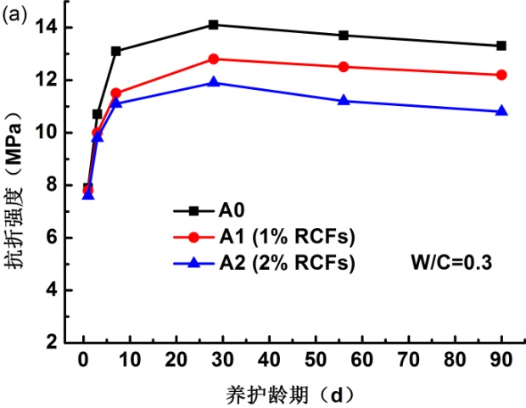
（a）抗折强度
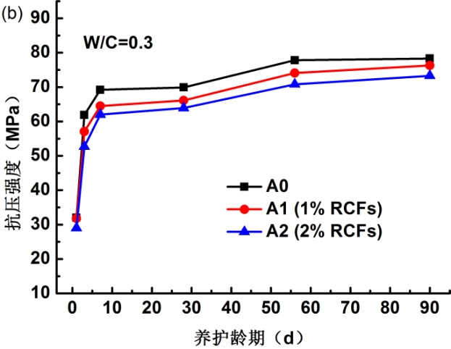
（b）抗压强度
图1 砂浆的抗折强度和抗压强度
Fig.1 Flexural strength and compressive strength of mortar
……
……
……
3 结论
1）水灰比……。
2）水灰比……。
……
……
参考文献：
[1] JIANG Z W, GUO X Y, LI W T, et al. Self-shrinkage behaviors of waste paper fiber reinforced cement paste considering its self-curing effect at early-ages [J]. International Journal of Polymer Science, 2016, 2016: 1-12.
[2] 陈海明, 黄凌昰, 沈朋辉, 等. 水胶比对高强砂浆早期收缩特性的影响[J]. 硅酸盐通报, 2018, 37(4): 1399-1403, 1429.
CHEN H M, HUANG L X, SHEN P H, et al. Influence of water/binder ratio on initial shrinkage of high strength mortar [J]. Bulletin of the Chinese Ceramic Society, 2018, 37(4): 1399-1403, 1429. (in Chinese)
……
……

收稿日期：2019-10-20 基金项目：国家自然科学基金(********)；重庆市自然科学基金(********) 作者简介：李****（1985- ），男，博士，副教授，主要从事钢筋混凝土结构研究，E-mail：***@******* 王****（通信作者），男，教授，博士生导师，E-mail：***@*******。 Received: 2019-10-20 Foundation items: National Natural Science Foundation of China (No. ********); Natural Science Foundation of Chongqing (No. ********) Author brief: LI **** (1985- ), PhD, associate professor, main research interest: reinforced concrete structure, E-mail: ***@******* WANG **** (corresponding author), professor, doctorial supervisor, ***@*******.

