Experimental analysis of seismic performance ……
LI **** ^{1a}, WANG ****^{1b}, ZHANG****²
(1a. School of Civil Engineering; 1b. College of Environment and Ecology, Chongqing University, Chongqing 400045, P. R. China; 2. College of Civil Engineering, Tongji University, Shanghai 210092, P. R. China)
Abstract: Early age cracking causing by shrinkage is one of the important factors for the deteriorations of concrete, the extension and extension of cracks can be slowed down or even reduced by adding fibers. ……
Keywords: reinforced concrete structure; seismic performance; experimental analysis; ……
***结构抗震性能试验研究
李****^{1a}，王****^{1b}，张****²
（1.重庆大学 a.土木工程学院；b.环境与生态学院，重庆 400045；2.同济大学 土木工程学院，上海 210092）
摘 要：早期收缩开裂是导致混凝土劣化的重要因素之一，纤维的加入可以延缓甚至减少裂缝的延伸及扩展。通过……研究……。研究结果表明：……。
关键词：钢筋混凝土结构；抗震性能；试验研究；……
中图分类号：TU375.4 文献标识码：A

1 Introduction
Anaerobic digestion by mesophilic or thermophilic bacteria is traditionally used as a primary treatment for piggery wastewater to reduce organic matter, waste volume, and odors and to recover biogas ^{[1]}. However,
…
…
2 Materials and methods
2.1 Test apparatus
Fig. 1 shows the model testing system…
…

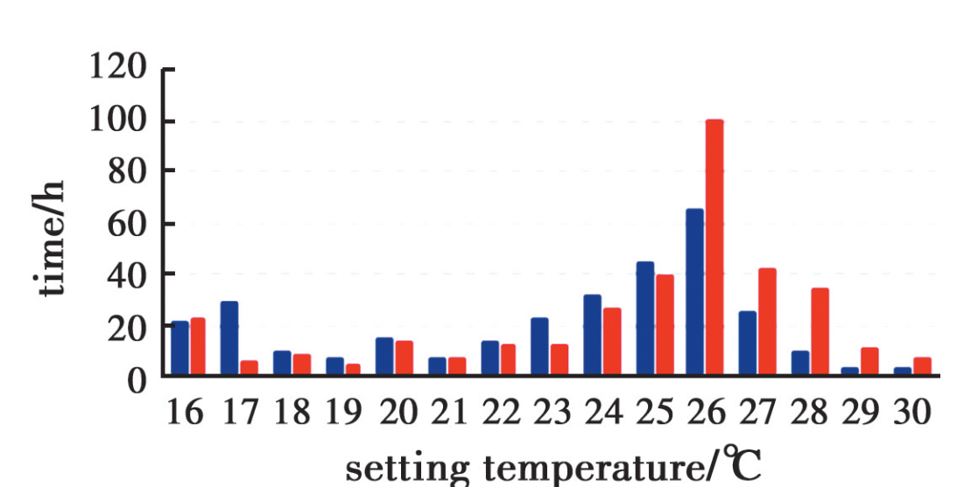
Fig. 1 Layout of the model testing system

2.2 Test materials
2.2.1 Surface settlement
For both surface settlement and subsurface settlement, six tests which can be divided into two groups are performed in this study, respectively (shown in Table 1)
…
…

Table 1 Mix proportion of mortar
group | W/C | water/(kg·m⁻³) | cement/(kg·m⁻³) | sand/(kg·m⁻³)
A1 | 0 | 0 | 0 | 0
A2 | 0 | 0 | 0 | 0
B1 | 0 | 0 | 0 | 0
B2 | 0 | 0 | 0 | 0

3 Results and discussion
3.1 Wastewater
The experiment was carried out in an incubator …
…
…

4 Conclusion
1) In conclusion, …
2) Similar conclusions can be drawn from…
…
…
References:
[1] JIANG Z W, GUO X Y, LI W T, et al. Self-shrinkage behaviors of waste paper fiber reinforced cement paste considering its self-curing effect at early-ages [J]. International Journal of Polymer Science, 2016, 2016: 1-12.
[2] NOIKE T, GOO I S, MATSUMOTO H, et al. Development of a new type of anaerobic digestion process equipped with the function of nitrogen removal [J]. Water Science & Technology, 2004, 49(5/6): 173-179.
…
…

Received: 2019-10-20 Foundation items: National Natural Science Foundation of China (No. ********); Natural Science Foundation of Chongqing (No. ********) Author brief: LI **** (1985- ), PhD, associate professor, main research interest: reinforced concrete structure, E-mail: ***@******* WANG **** (corresponding author), professor, doctorial supervisor, ***@*******.

